A Pub/Sub-based Wireless Video Surveillance System
Author 1  Stanford University  abby@bank-acm.edu | Author 2  Stanford University/ Intuit  burt@institution.edu | Author 3  Stanford University  jones@school.edu | Author 4  Stanford University / Google  ross@affiliation.com

ABSTRACT

Copyright is held by the author/owner(s).
UbiComp’11, September 17–21, 2011, Beijing, China.
ACM 978-1-60558-843-8/10/09.

In most of the existing video surveillance systems, captured video streams by CCTV or video cameras are aggregated through cables to a central station and monitored by associated human operators. However, because of the high deployment cost, these systems are neither flexible nor scalable, and using human to monitor events can be unreliable. To address these problems, we designed a wireless video surveillance system based on pub/sub. This system uses wireless sensor nodes to detect the pre-defined events and utilizes wireless mesh network to transmit high-quality video streams. Without cables, the deployment cost is significantly decreased. Using this system, different application users can freely define various events they are interested and automatically get event notification and corresponding video streams once the events occur. In this demo, we introduce the design of hardware and software architecture of wireless video surveillance system. This system is implemented on our intelligent transportation system testbed.

Author Keywords Video Surveillance, Wireless Sensor Networks, Wireless Mesh Networks, Publish/Subscribe, Composite Event Detection

ACM Classification Keywords C.2.1 [Network Architecture and Design]: Wireless communication

General Terms Design

INTRODUCTION
Video surveillance has found applications in many fields including intruders or criminal activities detection, traffic control or traffic accidents reporting, etc. In traditional video surveillance systems, video cameras capture the appearance of a scene electronically and the video streams from different video cameras are aggregated through cables to central station to be observed by a human, analyzed by a computer, or stored for later observation or analysis.

These video surveillance systems have some disadvantages. First, the time and the cost for the deployment of the associated long cables can be significantly high if the central station is located far from the monitored area or if the area is large. Second, using human to monitor events is also not efficient and important events of interests are easily to be omitted. Although image processing techniques have been used to help the human operators, processing the image captured by video camera along cannot give reliable and comprehensive understanding of ongoing activities in real environments. Third, current video surveillance systems are not flexible. Each system is designed for its own particular purpose. Moreover, these systems normally do not have support for mobile users and information stored in the systems is accessed only at designated locations (e.g. control centers).

In this demo, we proposed a wireless video surveillance system. Compared with traditional wire-based video surveillance system, this system has three distinctive properties. First, this system uses wireless communication instead of cables to deliver video streams thus the deployment cost is much lower compared with the wire-based counterpart. Second, different from existing video surveillance systems where video streams are continuously and passively transmitted to a central station, our system is event-triggered. When an event occurs, the notification along with the corresponding video streams are automatically transmitted to the application users. Third, compared with the existing video surveillance system, this system is flexible in terms of many aspects. Instead of staying in the control center, authorized users, even when roaming, can get notification and videos from anywhere covered by the deployed wireless mesh nodes. Also, this pub/sub system is able to support different types of application users simultaneously. They can easily define the events they are interested and when an event occurs, the video streams are automatically transmitted to the corresponding application users who subscribe this event.

The hardware architecture of this system is illustrated in Fig. 1. The system has two layers: In the bottom layer, a number of wireless sensor nodes are deployed in the monitored areas. These wireless sensor nodes are normally low cost, battery powered, have limited bandwidth and contain various types of sensors. They constitute a WSN and are responsible for receiving events subscription from users, detecting and publish the corresponding events. In the upper layer, a WMN is established using wireless mesh nodes. Compared with wireless sensor nodes in the bottom layer, mesh nodes are smaller in number, but have much higher bandwidth. Acting as the wireless backbone, the WMN supports transmission of high- quality video streams. Since different wireless frequencies are used in WSN and WMN, to communication with WSN, some wireless mesh nodes are attached with gateway nodes which are able to communication with wireless sensor nodes. Also should be noted is that wireless sensor nodes are divided into a number of clusters. Each cluster is normally used for sensing data in one particular area.
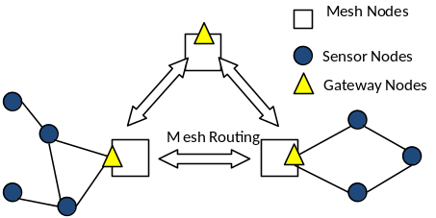
Figure 1. System Architecture
In terms of software, pub/sub mechanism is implemented in this system. Events defined by application users are subscribed, through the WMN, to the wireless sensor nodes in WSN. In particular, we use a middleware architecture named PSWare. PSWare features a layered design. On the top layer, it provides Event Definition Language (EDL) so that applications can easily define and subscribe to events. On the bottom layer, it uses a runtime environment so that different composite event detection mechanisms may be easily integrated. The figure below shows the basic operation for PSWare. Application will first define the events using EDL. Then the event definition will be compiled and disseminated into the network and installed on each sensor node. Once the subscribed events are detected, the events will be delivered to the application.
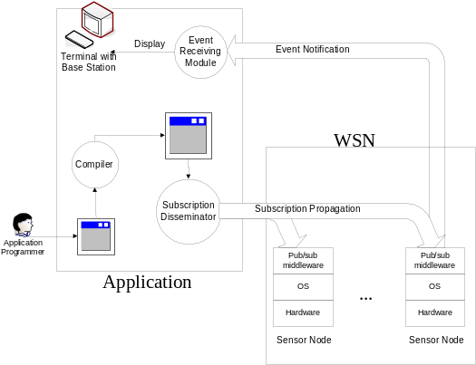
Figure 2. PSware
PSWare is different from existing event-based middleware for WSN because of its support for composite events. Composite events consist of multiple levels of sub-events and represent the relations among them. For example, the code below shows how a traffic jam can be defined. First, a car event is defined to indicate the car’s identity and the road it is current on. Then, traffic jam occurs when the total number of cars on a specific road exceeds a threshold.
event Car {
int carID;
int roadID;
}
event TrafficJam {
} on {
Car c;
} where {
c.roadID = 1 &&
count(c) >10
}

Due to the resources constraints of WSN, composite events are more difficult to manage. In PSWare, we use type-based event processing mechanism because the composite events can be more easily defined by specifying the types of the sub-events and their relations. By making use of the type information, we use a distributed type-based event detection algorithm, TED [1], for efficient composite event detection.

In video surveillance systems, most of the user-defined events, such as traffic jams, intrusion of burglars, are composite events and the detection of these events normally requires collaboration of multiple wireless sensor nodes. Considering the limited power supply and the energy consumed in wireless communication, transmitting all the measured data from each sensor node to the gateways is not a good choice. To use wireless sensor nodes to detect composite events in a reliable and energy-efficient way, we designed a distributed composite detection scheme in WSNs. The basic idea is that…..
In this demo, the performance of our proposed wireless video surveillance system is tested using our intelligent transportation system (ITS) platform.
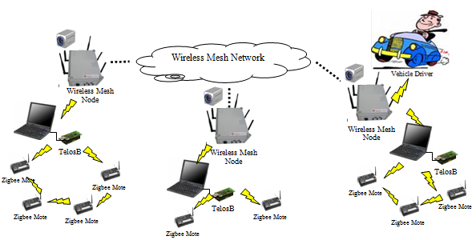
Fig. 3 Implementation
In the bottom layer, we deploy a number of IC tags below the surface of the road of this platform. Each model car is equipped with an IC card reader which is able to collect the information of the IC card it is passing by so as to determine its real-time location. On the top of each model car, a Crossbow MicaZ mote is installed for wireless communication. The IC tags, model cars and the attached MicaZ motes constitute a WSN.

In the upper layer, our self-developed T903 wireless mesh routers are used to set up a WMN. WMN is in charge of transmitting video streams captured during the occurrence of events. Each T903 node has three wireless network interface cards (NICs) including one 802.11b/g NIC for client access and two 802.11a NICs for backbone transmission.

We also use a number of laptop computers each attached with a TelosB mote to connect the WSN and the WMN together. The laptop computers serve as gateway nodes which connect to the WMN through the embedded WLAN card and communicate with MicaZ motes through TelosB. Every laptop computer will connect with a batch of MicaZ motes to form a small cluster for event detection.
We define a number of events in this demo:
- User-defined Traffic jam
- Collision of two cars
- When a specific car enters a certain area
For the traffic jam, application users can give different definition such as ‘there are 4 cars in a certain area’.

REFERENCES
- Steven Lai, Jiannong Cao, Xiaopeng Fan, “TED: Efficient Type-based Composite Event Detection for Wireless Sensor Network”, 7th IEEE International Conference on Distributed Computing in Sensor Systems, June 27 - 29, 2011, Barcelona, Spain
- It is recommended to have the references/citations ragged right/flush left. This way items with long string urls (web addresses) do not cause lines or entries to be letter and word spaced.
- Anderson, R.E. Social impacts of computing: Codes of professional ethics. Social Science Computing Review 10, 2 (1992), 453-469.

BALANCE THE LAST PAGE INTO TWO AS EVEN COLUMNS AS POSSIBLE, BY NOT DELETING THIS LINE, JUST DELETE THE TEXT.

